What is Culture?

When you think of culture, what do you think of?

What are some examples of cultures? Does a culture always have to be a nationality?

Culture is defined as “the arts and other manifestations of human intellectual achievement regarded collectively.”

Oh, that’s all well and good but what does that even mean!?! Write your answer below.

Now, let’s describe the British culture together. When you think of British culture, what do you think of?

Now, by yourself, choose another culture to describe just like we did above.

Etymology: Word Origins

Where do words come from? How did we even come up with a word like pirate or phrases like “raining cats and dogs”? Each word or phrase has its own story and we’re going to explore this a bit.

On the map on the next page we will research the official language of some countries and label them on the map.

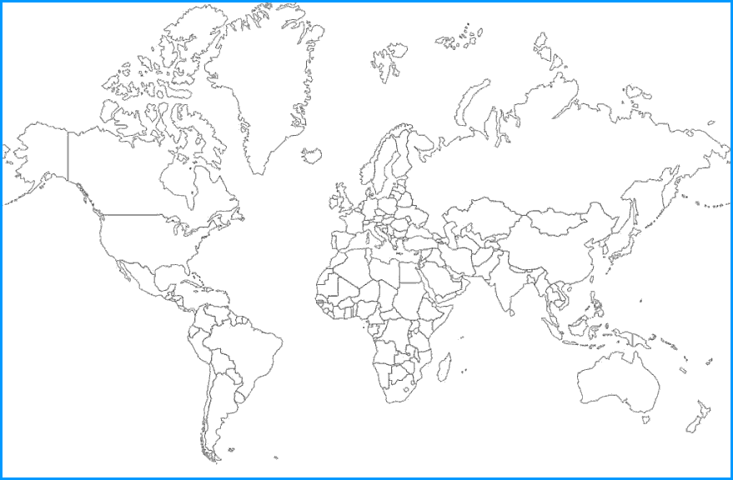

What is something that surprised you about the map of languages?

How do you think those languages spread geographically?

How do you think these languages started?

Do you think the words we say have the same meaning in other cultures that may speak the same language? Do you think the words we say have the same meaning as they may have 100 or more years ago? Explain.

Let’s find the etymology of the word “phony”.

Current Definition: an adjective that describes something that is fake or an imitation
But where did it come from?
British thieves had a code word for a gilt ring (a ring made to look like it was gold) – fawney. They would sell it and say it was made out of real gold.

Fawney Phony

Word are often mutations of words in other languages, combinations of smaller words, or gradual changes to the meaning through use in different contexts.

Try it yourself! Pick and word or two and research it’s current mean and origin. Be sure to draw a diagram to show how the word changed.

Latin Culture and Language

Latin Culture
Station 1: Roman Empire:
- How was distance measured on a Roman road?
- What did the ships (vessels) usually carry on board (name at least 5 items)

- What benefits did the people have under Pax Romana (Roman Peace)?
- Fill in the blank: Fall of the Empire
- “The huge Roman Empire was and to run.”
- “By the third century AD, the army was and were
to cover the Empires costs.”
- “ wars raged, and sensing the Empire’s attacked the .”

Station 2: Architecture
- List the 12 components (parts) of a Roman Villa:

- What type of tiling did the Romans use to decorate their walls and floors?
- What are the three types of rooms in the bathhouse?
; ;
- How long did it take for 50,000 people to exit the Coliseum?

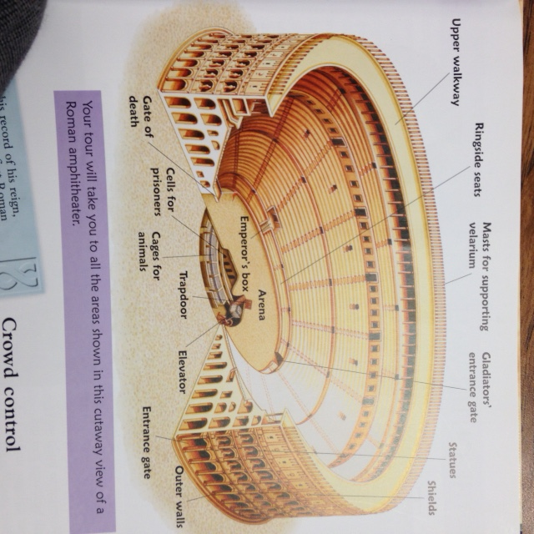
- Fill in the blank spots on the Coliseum. Use the word bank to the right of the image.

Word Bank:

Statues Outer Walls

Trapdoor

Gate of Death

Ringside Seats

Gladiators entrance gate

Arena
Station 3: Religion
- Name the culture the Romans base many of their gods off of?
- How are Pluto (Hades) and Jupiter (Zeus) related?
- What was Diana goddess of and who is she a patron of?
- Which god would mothers typically worship?
- Which god would sailors and fishermen typically worship?
- Label the images of the Gods and Goddesses below: Jupiter Neptune Ceres Diana
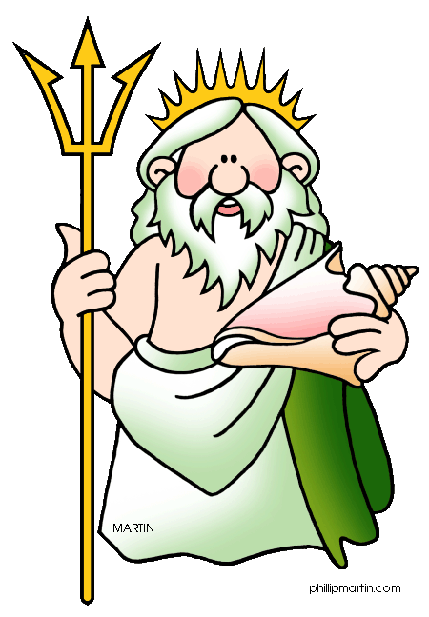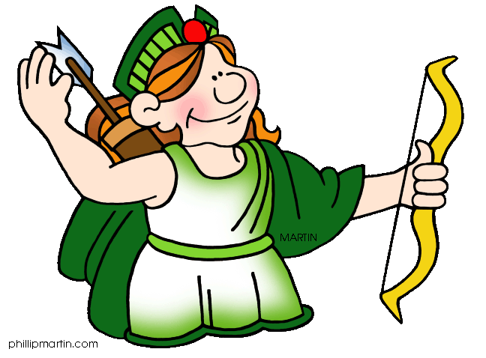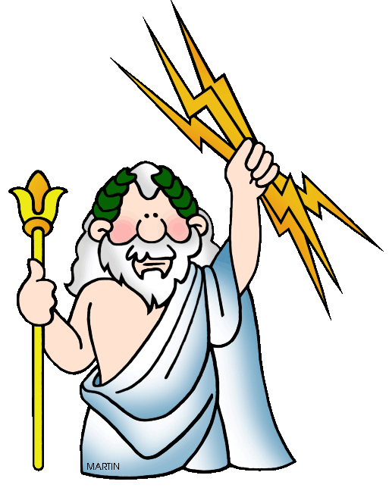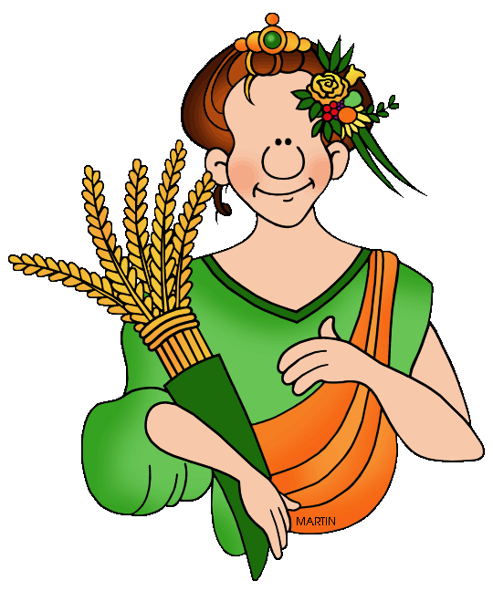

Station 4: Daily Life (Tales of the Dead: Ancient Rome)
Children in Rome (p. 18-19)
- What types of families sent their children to school?
- Which gender (boys or girls) were typically educated?
- Fill in the blank:
“Roman girls weren’t educated after the age of . Girls were allowed to at and very few were still single by the age of . “
- What were male children expected to do when they grew up?
- What types of games did they play?
Living in Rome: (p. 20-21, 25, 30-31)
- How did people in the city get water?
- What would the Romans do on the walls of city buildings?
- What did the Romans eat? (list 5 items)

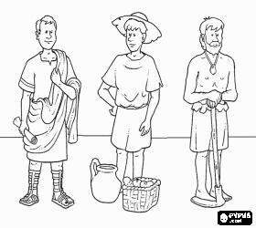
- What forms of entertainment did the Romans enjoy?
- Match the following labels with the people below based on how they are dressed and what they are doing: Patrician, Slave, and Plebian.

1.

2.

3.

Pompeii:
- Why is Pompeii famous today? What happened there? When did it happen?

Latin Language
- Write the Roman / Latin Alphabet below.

- How is the Latin Alphabet different from our alphabet?

- Write the correct Roman Numeral below these numbers.

1 2 3 4 5 6 7

8 9 10 50 100 500 1000

Spanish Language
English Number | Spanish Numbers & Colors
One
Two
Three
Four
Five
Six
Seven
Eight
Nine
Ten
Red
Blue
Green
Yellow
Purple

English Words and Phrases | Spanish Words and Phrases
Hello! How are you?
My name is…
Goodbye
Thank You
Bless You (after sneeze)
Please
Cat
Dog
Table
Man
Woman
Boy
Girl
Food
Excuse me

What trends do you see between the Spanish language and English?

Spain
Capitol:
Other Major Cities:
Continent:
Official Language(s):
Main Religion(s):
Climate:
Famous People:
Currency:
Major Exports:
Interesting Facts: Write in complete sentences

Argentina
Capitol:
Other Major Cities:
Continent:
Official Language(s):
Main Religion(s):
Climate:
Famous People:
Currency:
Major Exports:
Interesting Facts: Write in complete sentences

What are some similarities and differences you see between the Spanish and Argentinean cultures? How are they similar or different to American culture?

French Language
English Number | French Numbers & Colors
One
Two
Three
Four
Five
Six
Seven
Eight
Nine
Ten
Red
Blue
Green
Yellow
Purple

English Words and Phrases | French Words and Phrases
Hello! How are you?
My name is…
Goodbye
Thank You
Bless You (after sneeze)
Please
Cat
Dog
Table
Man
Woman
Boy
Girl
Food
Excuse me

What trends do you see between the French language and Spanish and English?

France
Capitol:
Other Major Cities:
Continent:
Official Language(s):
Main Religion(s):
Climate:
Famous People:
Currency:
Major Exports:
Interesting Facts: Write in complete sentences

Ivory Coast / Cote d’Ivoire
Capitol:
Other Major Cities:
Continent:
Official Language(s):
Main Religion(s):
Climate:
Famous People:
Currency:
Major Exports:
Interesting Facts: Write in complete sentences

What are some similarities and differences you see between the French and Ivory Coast cultures? How are they similar or different to American culture?

German Language
English Number | German Numbers & Colors
One
Two
Three
Four
Five
Six
Seven
Eight
Nine
Ten
Red
Blue
Green
Yellow
Purple

English Words and Phrases | German Words and Phrases
Hello! How are you?
My name is…
Goodbye
Thank You
Bless You (after sneeze)
Please
Cat
Dog
Table
Man
Woman
Boy
Girl
Food
Excuse me

What trends do you see between the German language and French, Spanish, and English?

Germany
Capitol:
Other Major Cities:
Continent:
Official Language(s):
Main Religion(s):
Climate:
Famous People:
Currency:
Major Exports:
Interesting Facts: Write in complete sentences

Switzerland
Capitol:
Other Major Cities:
Continent:
Official Language(s):
Main Religion(s):
Climate:
Famous People:
Currency:
Major Exports:
Interesting Facts: Write in complete sentences

What are some similarities and differences you see between the German and Swiss cultures? How are they similar or different to American culture?

Country Research Project
Research a country of your choice! Pick a country that interests you and find out all about its language and culture. You will need to share your findings with your classmates but how you do that is up to you. Be creative!

You will be assessed in the following categories:

Country Basic Facts (30%): Create a presentation that is accurate, interesting, attractive, and shows off the country you researched to your classmates. Your project should include:
- Basic Facts
  - Country name
  - Flag
  - Country capitol city and other major cities
  - Continent
  - Official language(s) spoken
  - Major religion(s)
  - What is the climate like (explain this in common terms, i.e. not “temperate” or “moderate”)?
  - Map of the country with major landmarks (major mountains, lakes, etc.)
  - What kind of government do they have?
  - Currency used
- Extended Facts
  - Interesting facts about the country
  - Brief history
  - Miscellaneous information
- Works Cited

Language & Culture (30%): Research the culture and language spoken in the country and come up with a creative way to share what you found with your classmates.
- Teach us at least 5 words or phrases!
- What is the history of the language? / Where did it come from?
- Are there any English words that we can trace their origin back to words in this language?
- Share one part of the culture that you think is really interesting and is a good representation of the culture

Creativity and Quality of Project (20%): Did you think outside the box? Did you put in your best effort?

Reflection (20%): Write a one page reflection fully answering the following prompts. Write in complete sentences.
- Why did you choose this country and language to research?
- What was your favorite part about researching this country and language?
- What did you find difficult about this project?
- What else do you want to know about this country?
- What is something you learned from your classmate’s projects?

Name:
Country:
CATEGORY | 4 | 3 | 2 | 1
Country Basic Facts (30%)  Score: ____ | - Includes all basic facts  - Interesting facts are interesting and reveal culture and language  - Excellent summary of the country’s history  - No grammar or spelling errors  - All statements are written in their own words  - Includes references for information, pictures, and other materials  - Went above and beyond. Awesome! | - Includes most (>75%) of basic facts  - Interesting facts are somewhat engaging and may reveal culture or language  - Good summary of the country’s history  - Few distracting grammar or spelling errors  - Most (>75%) statements are written in their own words.  - Great work but try stretching yourself a little more next time! | - Includes some (>50%) of basic facts  - Interesting facts are ok but not particularly interesting or may not reveal culture or language.  - Moderate summary of country’s history but may be missing some key information  - Some distracting grammar or spelling errors  - Some (>50%) statements are written in their own words.  - Good job but I know you can do better work. | - Includes few (<50%) of basic facts  - Interesting facts are pretty boring or do not reveal culture or language  - Poor summary of country’s history and / or missing much important information  - Many distracting grammar or spelling errors  - Few (<50%) statements are written in their own words.  - What happened? I know you can do much, much better!
Language & Culture (30%)  Score: ____ | - Teaches at least 5 words or phrases  - Excellent explanation of the history of the language.  - Shows clear understanding of etymology  - Includes at least 1 English word that can be traced back to this language and culture  - Excellent choice of part of culture to share  - Went above and beyond. Awesome! | - Teaches at least 3-4 words or phrases  - Good explanation of the history of the language.  - Shows good understanding of etymology  - Good choice of part of culture to share but I’m still a little hazy on what the culture is all about.  - Great work but try stretching yourself a little more next time! | - Teaches at least 2 words or phrases  - Fair explanation of the history of the language.  - Shows moderate understanding of etymology.  - OK choice of part of culture to share but I still don’t have a good grasp of what the culture is all about.  - Good job but I know you can do better work. | - Teaches at least 1 word or phrase  - Poor explanation of the history of the language.  - Shows poor understanding of etymology  - Poor choice of part of culture to share. I don’t understand how this is a good representation of the culture.  - What happened? I know you can do much, much better!
Creativity and Quality of Project (20%)  Score: ____ | - Uses materials or ideas in new, clever, and surprising ways.  - Excellent quality. Time, care, and thought were clearly put into the design and construction of project.  - Product is appropriate to the content.  - Went above and beyond. Awesome! | - Uses materials in somewhat new, clever, or surprising ways but some ideas are predictable.  - Overall good quality but could have put in more time, care, or thought in the design and construction of project.  - Product is fairly aligned to content.  - Great work but try stretching yourself a little more next time! | - May use some materials in new or surprising ways but overall rather predictable.  - Overall fair quality but needs to take more time, care, or thought in the design and construction of project.  - Product somewhat aligned to content but could be more appropriate.  - Good job but I know you can do better work. | - Use of materials is very conventional and lacks originality or creativity.  - Overall poor quality. Needs to take more time, care, and thought in the design and construction of project.  - Product is poorly aligned to content.  - What happened? I know you can do much, much better!
Reflection (20%)  Score: ____ | - Answers all prompts fully  - Answers all prompts in complete sentences  - No grammar or spelling errors | - Answers most (>75%) prompts fully  - Answers most (>75%) prompts in complete sentences  - Few distracting grammar or spelling errors | - Answers some (>50%) prompts fully  - Answers some (>50%) prompts in complete sentences  - Some distracting grammar or spelling errors | - Answers few (<50%) prompts fully  - Answers few (<50%) prompts in complete sentences  - Many distracting grammar or spelling errors

