Chess Rules Handout Name: __________________________________________

Chess: This is a strategic game in which the main goal is to use your army to capture the enemy king. There are two armies: White army, and the Black army. Both armies have the same pieces.

The Pieces
Name & Points | Picture | Symbol | Description | How it Moves
1 King  infinite points |  |  | The King is the most important piece in the army. If he is captured, the game is lost. | 1 square in any direction (forward, back, across, or diagonally)
1 Queen  9 points |  |  | The queen is the most powerful piece. | Any number of squares in any direction
2 Rook (Castles)  5 points  each | 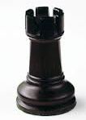 | 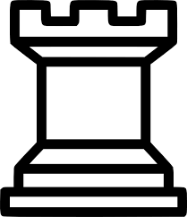 | Rooks are strong pieces which are good both at attacking the enemy and defending the King. | Any number of squares forward, back, or across (but not diagonally)
2 Bishops  3 points each | 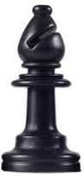 |  | Bishops are good at attacking late on in the game. Because they move diagonally, they always stay on the same color square that they start on. | Any number of squares diagonally.
2 Knights  3 points each | 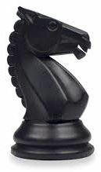 |  | Knights are at their best where there are lots of pieces on the board, and they are able to jump over other pieces (unlike any of the others) | “L-shaped” – two squares forward (or back) and one square across, or two squares across and one square forward (or back). The knight can jump over other pieces while doing this.
8 Pawns  1 point each | 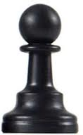 |  | Pawns are the foot soldiers in the army. They gradually advance on the opposing army, but also need to defend the King. | Usually one square forward. If it is capturing an opposing piece, it moves one square forward diagonally.  Each pawn can move two squares forward the first time it moves. Pawns can never move backwards.

How to Play
You need two players. Decide who will be White and who will be Black. Set up the board so you have a white square on the corner of the board by your right hand. Then place the armies on the board as shown in the picture below. Remember, Queen goes on her own color.
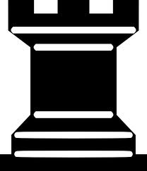 | 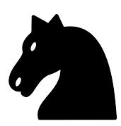 | 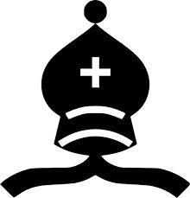
White and Black take turns to move a piece (in Chess, White army always goes first). Remember, each piece has its own way of moving as described above. A piece can capture an opposing piece by landing on that piece’s square. The aim of the game is to capture the enemy King. If you move one of your pieces to attack the King—in other words, your piece could capture him next move—you say “check”—this means, roughly “watch out for your King!” If you opponent can’t defend the King, you say “checkmate”—this means “the king is dead”. Remember that you must never move your King into “check” as this would mean your opponent could capture your King.

Fun Rules

Pawn Promotion:
Pawns are usually the slow-moving part of your army but if you manage to get a pawn to the last row of the board you can “promote” it to be a Queen (or a Rook, Bishop, or Knight if you prefer).

Castling:
Castling is a quick way to get your King into a well defended position by moving it toward the corner of the board. The rule sounds complicated but it is really very simple when you get the hang of it.

If there is nothing between your King and one of your Rooks (and neither the King nor that Rook have moved yet) then you can move your King two squares toward that Rook and put the Rook on the other side of the King. This is the only time a piece other than a Knight can jump over another piece. This is also the only time a King can move more than one space at a time.

You cannot castle a King out of check, into check, or across any squares that are under attack.

En Passant:
French for “in passing”. If a pawn moves out two squares on its first move and by doing so lands to the side of an opponent’s pawn (effectively jumping past the other pawn’s ability to capture it), the opponent’s pawn has the option of capturing the first pawn on their next turn.

J’Adoube:
French for “I adjust”. In chess, if you touch a piece, you must move that piece unless you first say J’Adoube.

Tips for a Good Game

Start off by using your central Pawns to try and control the middle of the board.

Use your other Pawns to defend the central Pawns and each other.

Move your Knights and Bishops out from the back row early on (this is called “developing your pieces” and means you are using the full strength of your army).

Be cautious with your Queen at the start—try to not waste time moving her away from enemy attacks.

Try to keep your King defended by your Pawns (castling is a good way to do this).

Tracking Your Game

- Each line of squares going up and down the board is called a “file”. For example, at the start of the game, both Kings are on the same file. Files are lettered with small letters: a, b, c, d, e, f, g, h. No matter what color you play, the “a” file is always on White’s left and Black’s right. The Kings are on the “e-file”.
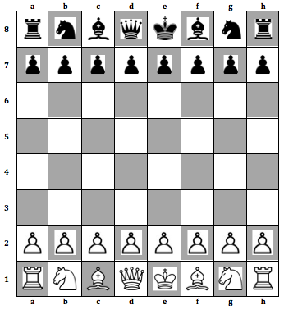
- Each line of squares going left to right across the board is called a “rank”. For example, at the start of the game, all your pawns are on the same rank. Ranks are numbered 1, 2, 3, 4, 5, 6, 7, 8. The first rank is always where White sets up his major pieces; the eighth rank is where Black sets up his major pieces. No matter what color you play, the rank in front of Black is always #8.

- Each square is identified by its file and rank so at the start of a game, White sets up his King on e1 and Black sets up his King on e8.

- Each piece has a capital letter associated with its name. The King = K; Knight = N; Queen = Q; Rook = R; Bishop = B. There are so many pawns that no letter is used for a pawn.

- Moving: write the letter for the piece that moved followed by the name of the square it moved to. For example: Ke2 or Qh5 or Bh8 or Nf6. For pawn moves you just write the destination square: e4, e5, h8. Remember, Capital letters are pieces, small letters are files.

- If more than one piece of the type that moved can move to the same destination square, put the name of the rank or file where the piece came from after the piece name to make the move unique: Rae1 or N8d7.

- Capturing: put an “x” between the name of the piece and capture the square: Kxe2, Qxh5. When you capture something with a pawn, instead of putting the name of the piece on the left, you put the file (not the square) it came from, then the “x” and the square that it captured. For example: dxe5 or hxg6.

- Pawn Promotion: indicate the square and the promoted piece: a8Q, c1N.

- Castling: you write O-O for kingside, O-O-O for Queenside.

- Check: is indicated by a plus at the end of the move: Rh8+ or Qxe2+. Mate can be “#” or “mate”.

Keep track of the game and the pieces you capture by using the following worksheet (2 pages).

Date: |  |  | Winner:
White: |  |  | Black:
 | White | Black |  | White | Black
1 |  |  | 22
2 |  |  | 23
3 |  |  | 24
4 |  |  | 25
5 |  |  | 26
6 |  |  | 27
7 |  |  | 28
8 |  |  | 29
9 |  |  | 30
10 |  |  | 31
11 |  |  | 32
12 |  |  | 33
13 |  |  | 34
14 |  |  | 35
15 |  |  | 36
16 |  |  | 37
17 |  |  | 38
18 |  |  | 39
19 |  |  | 40
20 |  |  | 41
21 |  |  | 42
 | White | Black |  | White | Black
43 |  |  | 50
44 |  |  | 51
45 |  |  | 52
46 |  |  | 53
47 |  |  | 54
48 |  |  | 55
49 |  |  | 56

Scoring
 | Piece | Points |  | Piece | Points
W  H  I  T  E |  |  | B  L  A  C  K
 | Sub-Total |  |  | Sub-Total
 | + Win Bonus (15 points) |  |  | + Win Bonus (15 points)
 | Total |  |  | Total

