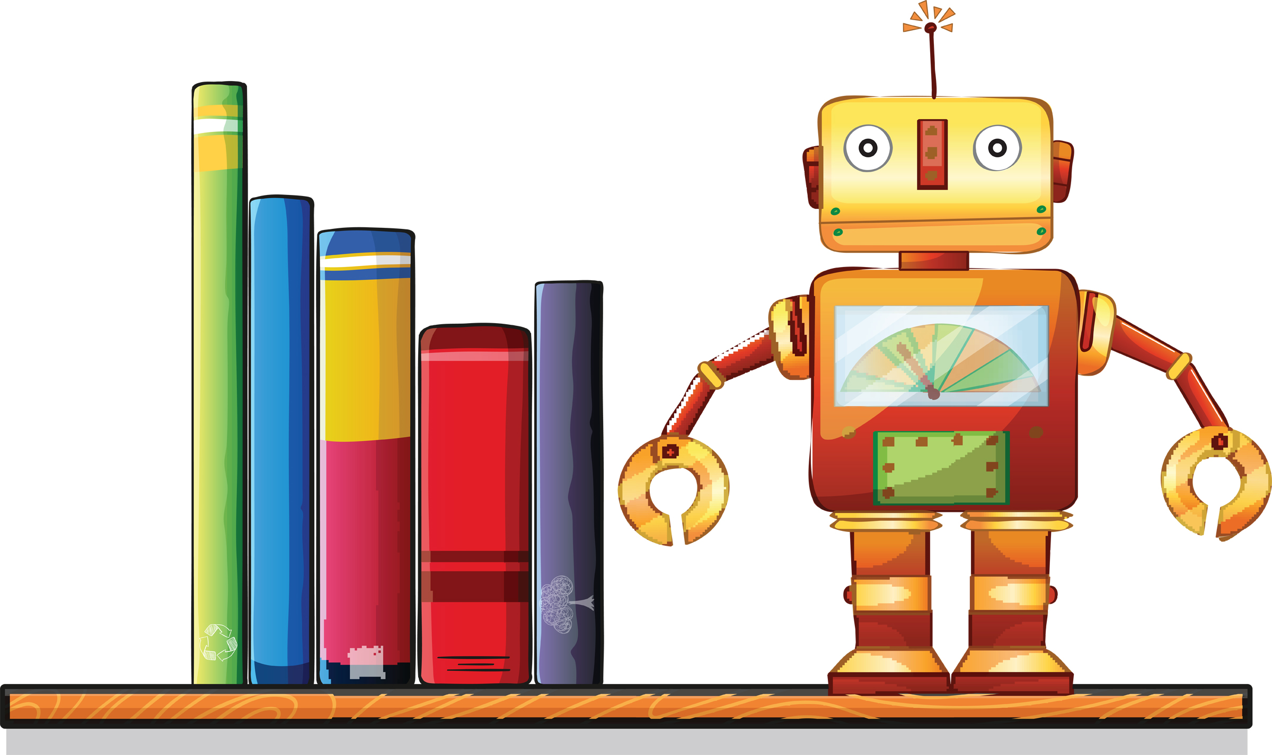
Contact Information:
Ms. Reilly Belton
Email: rbelton@rockingham.k12.va.us
EMS Room #: 210 EMS phone: (540) 298-1228

Course Description:
This is an introductory robotics course. The class will cover the history of robotics and technology as well as how robots are being used for solving real world problems in health, industry and the military. Students will build and program robots using LEGO Mindstorms Robotics kits.

Materials: Students are expected to be prepared with notemaking materials everyday.

Assessment:

10% Participation
10% Monthly Tic-Tac-Toe Assignments
10% Classwork / Homework
15% Engineering Logs
20% Quizzes / Checkpoints
35% Tests / Projects

Policies and Expectations:
Grades: Letter grades will be administered as follows:
A (90-100) Outstanding Work
B (80-89) Above Average Work
C (70-79) Average Work
D (60-69) Below Average Work
F (59 and below) Poor Achievement/Failing
Grades can be found in PowerSchool and will be current and entered on a weekly basis when there are graded assignments.
Make Up Work: The grade-level make up policies apply to class work missed during an absence. Robotics offers hands-on, in-class assignments that would often be impossible to replicate outside class. Therefore, if a student is absent, it is important that he or she asks Ms. Belton for a way to make up participation credits. (See EMS Student Handbook, 2015-2016)
School Planner: Every EMS student has a school planner. This planner will be used daily in this class and time will be given at the end of the class for students to put in assignments, late work, upcoming events, and may be used for communication. Please check your child’s planner for assignments and pertinent class information.
Late Work: Eighth Grade – Late homework assignments will not be accepted in the 8th grade. Please make sure your assignments are in by the due date. Late projects will lose 10% every day it is late. One day for every excused absence is given for missed assignments. (EMS Student Handbook, 2015-2016)
Cell Phones: RCPS school board has implemented a policy allowing middle school students to have their phone with them, but turned off. Cell phones are not to be used for social reasons in the middle school. The first offense will lead to a warning, the second offense will result in the cell phone being taken to the office and 1 day of ABIP, future incidents will lead to out of school suspension and loss of cell phone being brought to school. (EMS Student Handbook, 2015-2016)
Classroom Behavior: Elkton Middle School believes that “Character Counts!” There are six “Pillars of Character”: Trustworthiness, Respect, Fairness, Caring, and Citizenship. These pillars help us interact with others, be confident, and contribute to our community. I expect these behaviors of myself and I expect them of my students as well.
Prime Time: New this year is a daily 47-minute class period (graded) that will focus on reading, remediation and relationship.

Standards:
- Robotics Standards:
  - The student will demonstrate group, teamwork, and leadership skills such as responsibility and delegation, time management, cooperation, initiative, feedback, and encouragement to accomplish tasks.
    - Use technology tools for individual and collaborative writing, communication, and publishing activities.
    - Assume different roles on teams in various situations.
  - The student will communicate the history of robotics and programming to include concepts such as:
    - Famous programmers and developers (Alan Touring, Bill Gates, etc.)
    - Programming and computer languages (binary code)
    - Sequential and logical thinking, if / then statements
  - The student will use robots and programming to accomplish tasks.
  - The student will solve problems and communicate information in a variety of professional and creative methods.
    - Use digital research to support written and oral presentations.
    - Evaluate the accuracy, relevance, and appropriateness of electronic information sources.
  - The student will demonstrate an operational knowledge of various technologies, and identify and use available technologies to complete specific tasks.
    - Use various types of technology devices to perform learning tasks.
    - Communicate about technology with appropriate terminology.
    - Use content-specific tools, software, and simulations to complete projects.
  - The student will exhibit personal responsibility for appropriate, legal, and ethical conduct.
    - Demonstrate an understanding of “fair use.”
    - Demonstrate an understanding of current copyright laws.
  - The student will plan and apply strategies for gathering information, using a variety of tools and sources, and draw conclusions from research and relate these findings to real-world situations.

Remind: Sign up for text messaging notifications for class assignments and due dates. Send a text message to 81010 with the message @741af to register.

About Ms. Belton: I graduated from James Madison University. I completed my Bachelor of Science in Biology and my Master of Arts in Teaching there and I now proudly wear the title of “Double Duke.” I also hold teaching endorsements in Algebra 1 and Gifted Education. Both my parents were in the Air Force so I moved around some during my childhood (Pennsylvania, Montana, and South Dakota) but I spent nine years in Idaho before my family moved out here to Virginia where I finished high school. In my years at JMU I came to love The Valley and I am very happy to be staying and be a part of the Elkton Middle School and East Rockingham High School teams!

