CRIBBAGE

Cribbage Introduction and Basics
Cribbage is typically a two-player card game, but it can also be played by three or four players at a time. Sir John Suckling invented Cribbage in the early 1600s. He was an English courtier and was big into games and gambling.

Cribbage is very similar to an even earlier card game called Noddy. It first started out as a five card game but then evolved to be the current and popular six card game.

When the game emigrated to the United States, it became very popular with colonists and quickly spread. It was also very popular with sailors and fishermen. We typically see cribbage boards made out of wood and a rectangular shape but there is a history of very elaborate and unique cribbage boards. Eskimos made cribbage boards out of walrus tusks.

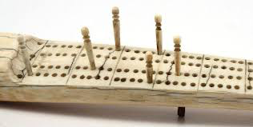
Below you’ll see a typical cribbage board on the left, and a unique cribbage board on the right.
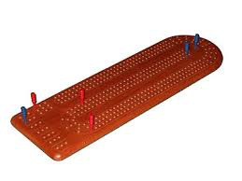

Cribbage Rules

Object of the Game
The object of the game is to be the first player to score 121 points. The cribbage board is used to show the score accumulated by each player during the play of the game (front peg) and the amount of the latest incremental score (difference between front and rear pegs). When adding points to your score, you use the back peg and count forward the number of holes starting at the front peg. Your back peg is now your front peg.

The Cards and Their Value
Card: K Q J 10 9 8 7 6 5 4 3 2 A
Value: 10 10 10 10 9 8 7 6 5 4 3 2 1

Basic Play
- The deck is cut to determine which player will deal first in the first game of the match; the low card wins the deal. In any subsequent game of the match, the loser of the previous game deals first.
- The dealer shuffles and, after a mandatory cut by the pone, distributes one card alternately to each player, beginning with the pone, until each has six cards.
- Each player discards two cards to form the crib, which belongs to the dealer.
- The pone cuts the remainder of the deck to select a starter card, which is used in counting the value of each player’s hand and the crib.
- Pegging:
  - Players alternately play (place face up on the table) one card at a time, starting with the pone. The cumulative value of the cards played is announced as each card is played.
  - When a player cannot play a card without the cumulative total exceeding 31, that player calls “go”, and the opponent continues to play all cards possible (not exceeding a 31-count). The player who calls “go” plays first in the following 31-count sequence.
  - Points are scored during this play of the cards (see Article III. Scoring Cribbage: Pegging)
- When both players have played all their cards in pegging, the pone’s hand is counted and pegged by the pone (see Article III. Scoring Cribbage: Counting Your Hand). The dealer then does the same for the dealer’s hand and then for the crib.
- The deal alternates between the players until the game ends, which occurs when a player scores 121 points.

Scoring Cribbage
There are SO many ways to earn points in Cribbage. It may seem like a lot to remember at first, but you will quickly catch on and be looking for the best ways to earn points in no time!

Pegging
Before you get to count the points in your hand, you and the other player(s) take turns playing cards and counting based on the face value of the card. You are trying to earn points by:
- making the count add to 15 when you play your card
- making the count add to 31 when you play your card
- playing a double (the same card the other player just played)
- playing a card to get a run of 3 or more (numbers in sequence)

15 or 31 2 points
Runs of 3+ 1 point for each card
Pairs (2 of a kind) 2 points
Pairs Royal (3 of a kind) 6 points (2 points for each pair)
Double Pairs Royal (4 of a kind) 12 points (2 points for each pair)
“Go” 1 point
Last Card 1 point

Practice
Practice pegging with a partner.

Write down the four cards in your hand and your partner’s hand.

3 Diamonds, 2 Diamonds, 3 Spades, Queen Hearts Jack Clubs, 2 Spades, A Hearts, 2 Clubs
Your Hand Partner’s Hand

Next, write down how the cards were played, the current count, and show where points were earned. See the following table for an example:

Card | Current Count | Points Earned
3 Diamonds (3D) | 3 | --
J Clubs (JC) | 13 | --
2 Diamonds (2D) | 15 | 2 (for the 15)
2 Spades (2S) | 17 | 2 (for the pair)
3 Spades (3S) | 20 | --
A Hearts (AH) | 21 | 3 (for the run: 2-3-A)
Q Hearts (QH) | 31 | 2 (for the 31)
2 Clubs | 2 | 1 (Last Card)

Use the following table to track your Pegging with a partner.

Your Hand Partner’s Hand

Card | Current Count | Points Earned

Counting Your Hand
When you count your hand, you not only use the four cards in hand, but the starter card as well. Use the following table to help you score your hand and score pegging.

 | Points Earned
Cards | During Pegging | Hand or Crib
Jack as Starter Card (His Heels) | 2
Jack in hand (His Nobs) | - | 1
Combinations
Pair | 2 | 2
Triple (three of a kind) | 6 | 6
Quadruple (four of a kind) | 12 | 12
Straights / Runs: per card | 1 | 1
15-count (sum of any combination or cards) | - | 2
Four-card Flush (only in hand) | - | 4
Five-card Flush | - | 5
Reaching a 15-count exactly | 2 | -
*Reaching a 31-count exactly | 2 | -
*“Go” (without reaching 31-count) | 1 | -
*Final card played (without reaching a 31-count) | 1 | -
*Only one of these scores can be earned with the play of a single card

Where’s the Math in Cribbage?
When you play Cribbage you are using basic math skills of arithmetic (primarily addition), combinations, and probability. You use arithmetic when you are Pegging, counting your cards, and adding to 15. You use combinations when you look for different ways to make 15. You calculate probability when you calculate the odds of a certain card being the starter card.

We’re going to take a look at each of these math skills a little more closely.

Arithmetic and Combinations
Part of playing Cribbage is recognizing different ways to add up to 15. In math, this is called a combination. In a combination, the order of the numbers doesn’t matter.

There are two types of combinations, both of which we use in Cribbage:
- No Repetition: such as lottery numbers or BINGO (2,14,15,27,30,33)
- Repetition is Allowed: such as coins in your pocket (5,5,5,10,10)
Now, I’m not going to get all hung up on the formulas to calculate all this (because that gets pretty messy) but I do want you to consider the different combination of cards that can add up to 15.

Assuming you have a deck of cards and 10s and Face Cards are all worth 10, Aces are worth 1.
- Write out the different 2-card combinations that add up to 15.

- Write out the different 3-card combinations that add up to 15.

- Write out the different 4-card combinations that add up to 15.

Probability
So, probability is a mathematical term for the likelihood that something will happen. Probability is measured on a scale from 0 to 1. A probability of zero means that an event happen. A probability of one means that an event happen.

You use probability very subtly in Cribbage – no calculations necessary while playing the game! However, it is important that when playing the game you know the rough probability of a certain card being chosen as the starter card. Knowing this will help you decide which cards to discard because you will have an idea of which cards have the highest probability of being the starter card.

Basic Probability
- At the very basic level, probability is:

- There are 52 cards in a deck of cards so the probability of drawing any one specific card, say a 4 of hearts, from a complete deck is:

- Suppose you didn’t care if it were the 4 of hearts, you just wanted to draw a 4 of any suit. There are four different 4’s in the deck, one in each suit. The probability of drawing any 4 is:

or

Extension of Probability
- Next, suppose you have a couple cards you would like to be drawn as the starter card. How do you calculate the probability of getting a card you want? Easy, you just add the probabilities! What is the probability of any 5 OR a 9 of Hearts OR any Queen turning up?

Example
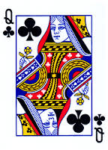
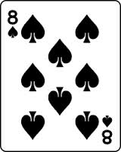
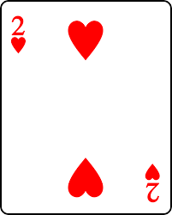
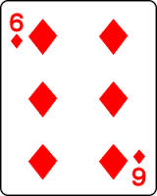
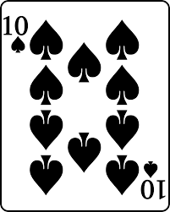
Now in Cribbage, suppose you were dealt the following six cards:
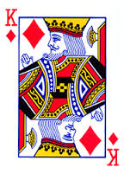
There are a couple options with this hand.
Option 1: Discard the 8 and 6 and hope for a 3 or 5 (so your cards will have different combinations of 15)
- What is the probability, or P(3 or 5), that either of those cards will turn up?

Option 2: Discard the King and Queen and hope for a 9, or 7 (so you will get a run and maybe a combination of 15)
- What is the probability that either of those cards will turn up?

- Now, based on the probabilities of the above options, which option would you pick and why?

Practice
A number cube is rolled. Find the probability of each event. Write each answer as a fraction, a decimal, and a percent.

- P(3)

- P(less than 1)

- P(multiple of 2)

- P(4 or 6)

- P(even)

- P(2,3, or 4)

Glossary
Crib The extra hand of four cards for the dealer. Nicknames include: cat and kitty.
Dead Hole The 120th hole (last hole before going out). Also known as the stink hole.
Double Skunk When a player fails to reach the 61st hole before their opponent wins the game.
First Street The first 30 holes on a cribbage board.
Flush Four cards of the same suit held in the hand count four points; five cards of the same suit (including the starter card) count five points in the hand or crib
Fourth Street The last 30 holes on a cribbage board.
Go A player says this during pegging when he / she cannot play a card from their hand without going over 31.
His Heels When a Jack is turned over as the starter card, counts two points for the dealer.
His Nobs When you have a Jack in hand that is the same suit as the starter card, either in the hand or crib, counts as one point.
Muggins This is said when an opponent either misses counting some points in his / her hand, or under pegs. Whoever said “muggins” then gets the points that were missed or messed up on.
Nineteen It is impossible to have a cribbage hand that equals 19 points, therefore, a 19-point hand means a hand that contains zero points.
Pair Two cards of the same rank, such as two Aces.
Pone The player who is currently not the dealer.
Second Street The second set of 30 holes on a cribbage board.
Skunk When a player fails to reach the 91st hole before their opponent wins the game.
Starter Card The card that is cut after both players have discarded their two cards into the crib. If the starter card is a Jack (also called Nibs or His Heels) it is worth 2 points to the dealer.
Straight (or run) Sequence of three or more consecutive cards in any order during pegging or in hand when counting
Third Street The third set of 30 holes on a cribbage board.
Twenty-Nine The best hand possible in Cribbage! Chances for getting this hand are more than 1:200,000.

