AVIATION

Forces of Flight

The Four Forces
Label the four forces of flight on this diagram. Draw arrows to show the direction of the force.

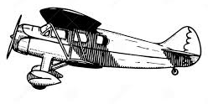

Define the four forces below. How do they contribute to flight?
Lift:
Thrust:
Weight:
Drag:

Airfoils and Lift
An airfoil is essentially the cross-section of a wing. The shape of the airfoil and the angle at which the front edge hits the air (angle of attack) are important factors in how well an airplane flies. When you think of airfoils you automatically think of wings but airfoils can be found in many situations: turbines, fan blades, bird wings, dolphin or whale flippers to name a few. Check out the diagram on the next page showing some of the many varieties of airfoils.

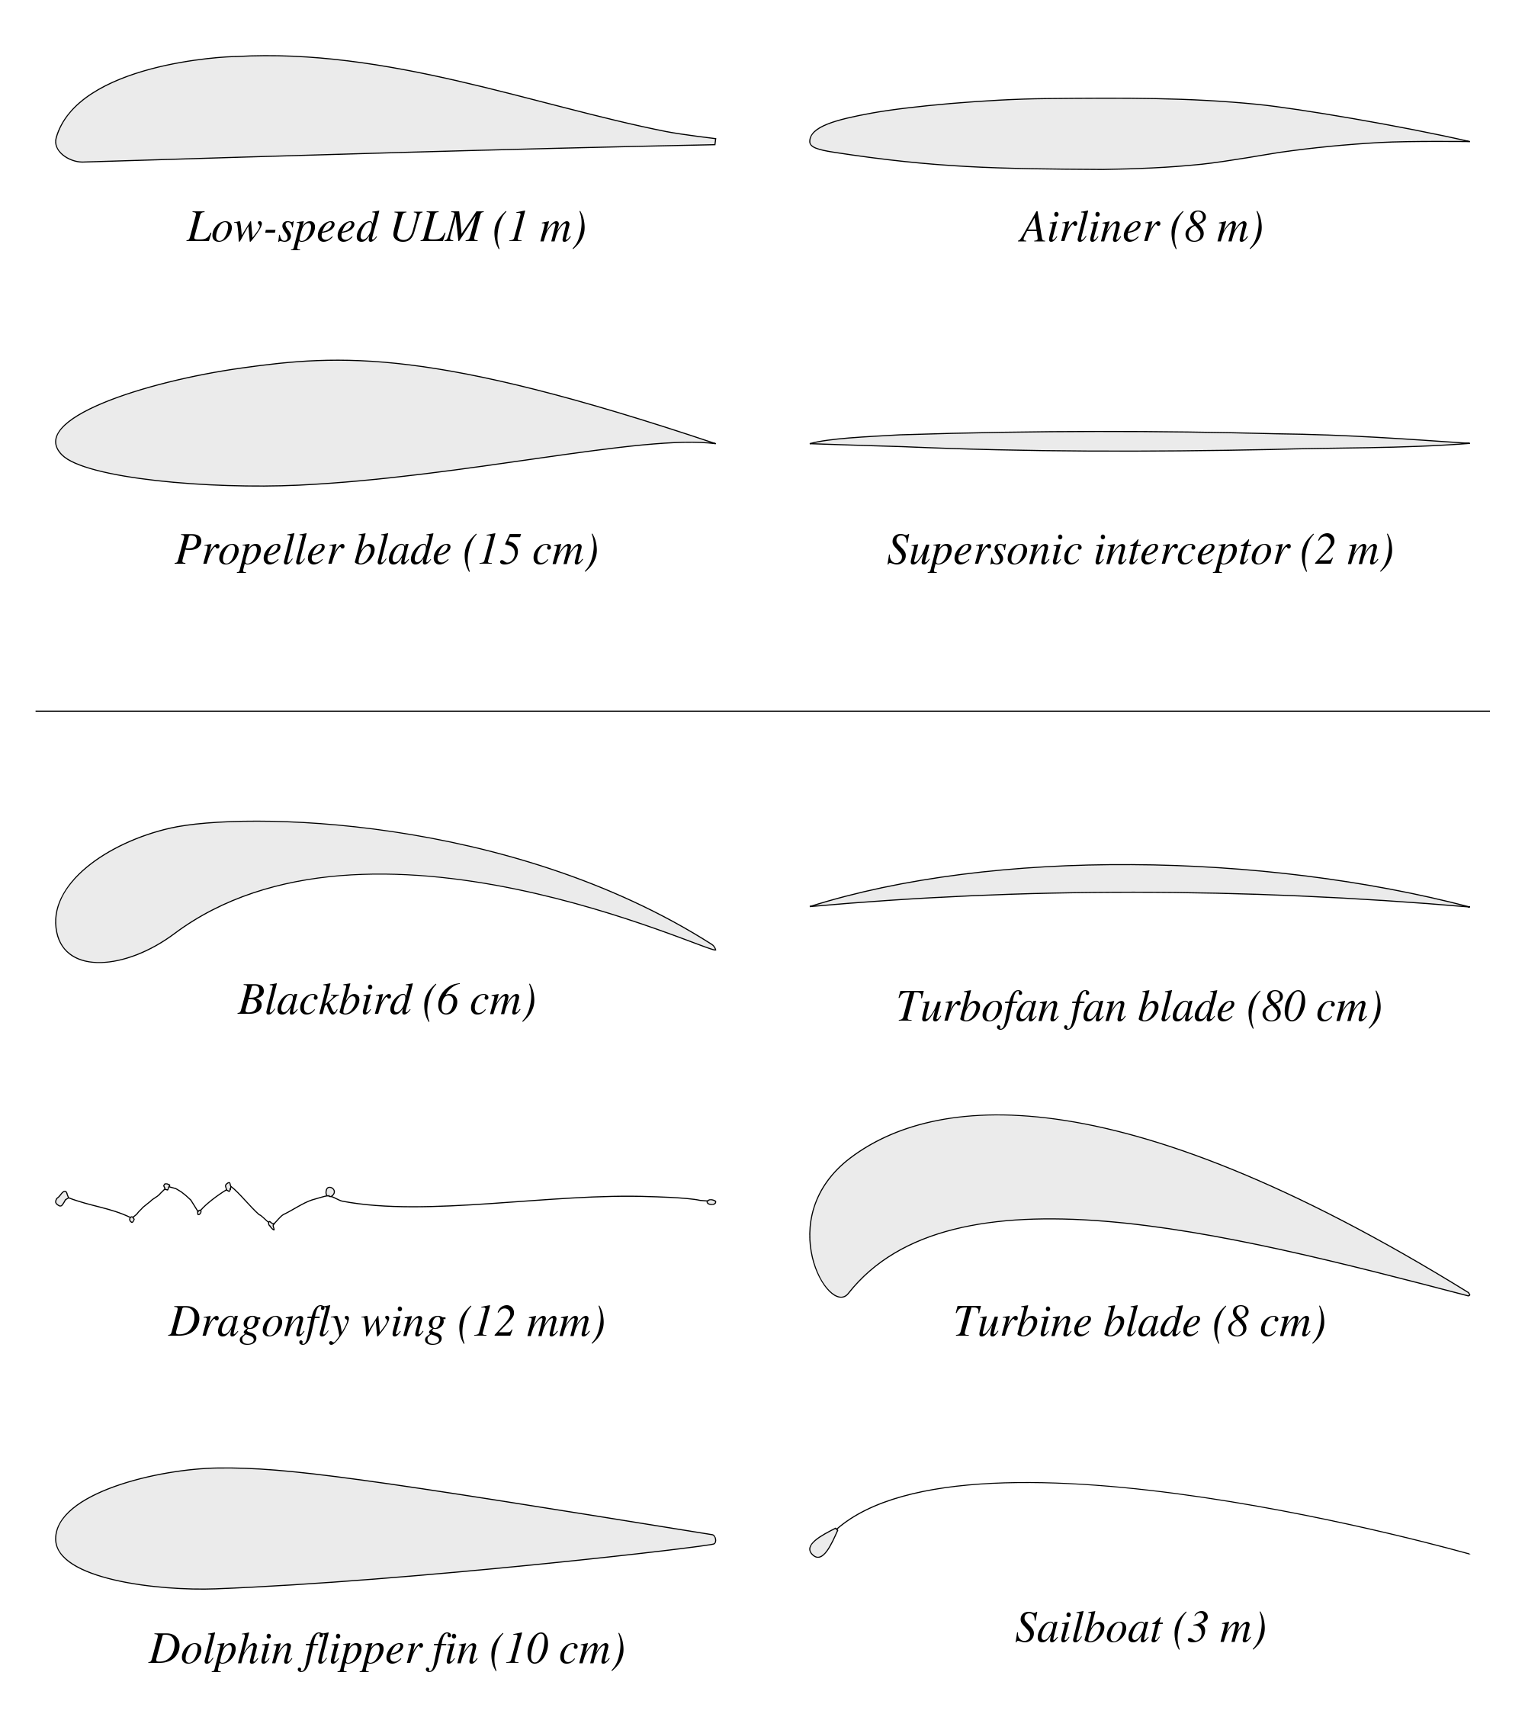

Scary, but it’s still a bit of a mystery exactly why planes fly however, engineers and physicists have isolated a couple of theories. Watch the following video (How Does a Wing Actually Work?: http://www.youtube.com/watch?v=aFO4PBolwFg) and explain each of the following theories and how they contribute to flight.

Newton’s Laws of Motion:

Bernouilli’s Principle:

Design an Airfoil - Project
Design an airfoil to maximize the lift generated. Use the provided rubric and what you know about airfoils to guide your design of your airfoil.

Airplane Design
Label the following diagram of the parts of an airplane. Note the function of each part.

Wing
Elevator
Rudder
Horizontal Stabilizer
Flaps
Aileron
Spoiler
Fuselage
Cockpit
Jet Engine
Slats
Vertical Stabilizer

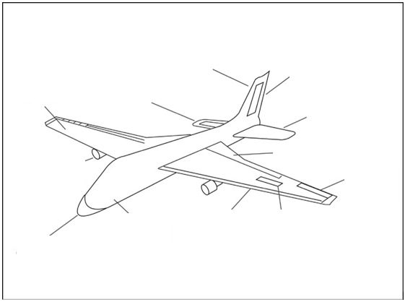

Airplane Communication

Runway Numbering
Runways are numbered 1-36 based on their approximate directional heading (degree) rounded to the nearest tenth, drop the zero. For example, a runway running exactly East-West is facing 90° one way and 270° the other. The East-facing end of the runway will be numbered 9 and the West-facing end of the runway will be numbered 27.

If an airport has parallel runways, these would be marked Left, Center, and Right (9L / 9C / 9R).

- How would a runway pointing SE with a heading of 110° be numbered?

- How would a runway pointing North with a heading of 355° be numbered?

- How would parallel runways pointing North with a heading of 4° be numbered?

Phonetic Alphabet

A
B
C
D
E
F
G
H
I
J
K
L
M
N
O
P
Q
R
S
T
U
V
W
X
Y
Z

Navigational Vectors

Scalars and Vectors
Suppose you wanted to tell someone how to fly from Harrisonburg to Richmond. How would you do that? Well, obviously you would need to tell them how far to travel and in which direction. These quantities are called distance and direction, respectively, and together are a value called displacement.

Distance is the measure of how far something – an airplane in this instance – would travel. It is a measure of length. This measurement should always include units in kilometers (km). This measurement is a scalar value.

Displacement tells you where something is (like a car or an airplane) in relation to where it was. This measurement is a vector.

But what are scalars and vectors? These are mathematical terms used to describe the type of number or measurement you are dealing with.

A scalar is just a regular number like your height, weight, money, number of hairs on your head, distance traveled, time elapsed, etc. A scalar number is only capable of communicating the quantity, or how large something is. This is called magnitude.

A vector is a number with a little more information so it tells us more than the magnitude. It also tells us direction. (Direction is written in degrees.) Think about a compass rose or a protractor. On a compass there are four main directions: North, South, East, and West. Each of these directions (and all the directions in between – NE, ENE, SWW, etc.) can be expressed by a number. We use the degrees of a circle to help us out. Take a look at the compass rose below:

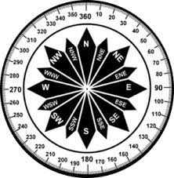

A circle has 360°. As you can see from the compass rose, the direction North aligns with 0° / 360°, East aligns with 90°, South aligns with 180°, and West aligns with 270°. We use these degrees to indicate the direction of travel.

A vector is typically drawn as an arrow: the length of the arrow tells you the magnitude and the direction the arrow is pointing communicates direction. The tail of the vector is where you start and the head of the vector shows where you end. For example:

Guided Practice
You will need a pencil, ruler, and a protractor to complete the practice problems.

- Find the distance and direction you would need to travel if you were to fly from Harrisonburg to Richmond, VA. Find the displacement of the trip.

Distance:
Direction:
Displacement:

- Find the distance and direction you would need to travel if you were to fly from Richmond, VA to Harrisonburg. Find the displacement of the trip.

Distance:
Direction:
Displacement:

- Find the distance and direction you would need to travel if you were to fly from Harrisonburg, VA to Washington, D. C. Find the displacement of the trip.

Distance:
Direction:
Displacement:

- If you walked 10 feet North and then 8 feet South, what is the distance you walked? What is the direction you ultimately walked? What is the displacement?

Distance:
Direction:
Displacement:

- The following information is important for pilots to know for any airplane flight. Write an “S” next to scalar and a “V” next to vector quantities.

Number of passengers
Plane speed
Plane velocity
Distance traveled
Flight displacement
Flight duration
Plane altitude
Acceleration of plane
Amount of fuel needed

Graphical Addition of Vectors
Graphically adding vectors uses the same skills you learned in the previous lesson on Scalars and Vectors. The idea of graphically adding vectors is that you can plan a trip with multiple legs and still measure the ultimate displacement from the original starting point. The basics of adding vectors:
- Draw the first vector on your map.
- Draw the second vector on your map.
- Draw a third vector (called the resultant) from the tail of the first vector to the head of the second vector, effectively creating a triangle.
- Measure the length of the resultant vector (in km) and its directional heading (in degrees) from your starting point to your ending point. The resultant represents the total displacement of the plan.

Practice
- Plan a flight from Richmond, Virginia to Chicago, Illinois with a stop over in St. Louis, Missouri.

Richmond to St. Louis (Vector 1)
Distance:
Direction:
Displacement:

St. Louis to Chicago (Vector 2)
Distance:
Direction:
Displacement:

Richmond to Chicago (Resultant Vector)
Distance:
Direction:
Displacement:

How do your measured displacements compare to the distance calculated on www.indo.com/distance?

Do your results make sense? Why or why not?

Wind Velocity

Flying in the Wind
Imagine that you are swimming in a river. Assume you are swimming at a constant rate.

- If you are swimming downstream, how does the current affect the distance you travel?

- What about if you are swimming upstream?

- What about if you are trying to swim across the river? How does the current affect where you end up on the other shore?

Flying a plane in the wind can produce the same effect. A pilot generally wants to fly in the shortest path between two cities. Why? Well, it saves time and fuel. The wind, however, may prevent the pilot from doing this. Check out the simulations on the following website to see how wind affects a plane’s flight: http://www.physicsclassroom.com/mmedia/vectors/plane.cfm.

- What do you think a pilot needs to do to compensate for wind?

Determining Wind Velocity
Winds in the northern hemisphere normally blow from west to east. This can change dramatically, however, when there is a front moving across the continent. Velocity is another example of a vector. Wind velocity is indicated by the wind speed and direction.

Pilots use wind maps that show the wind velocity at the altitude of the plane. A special symbol on the map called a wind barb shows both the speed and direction of the wind (wind velocity).

How to Read a Wind Barb
Reading wind barbs are not complicated. The use of wind barbs show both wind direction and speed. Think of them as arrows in terms of direction, with each barb at the tail representing speed. Reading wind barbs is similar to reading Roman Numerals. A full blacked triangle is 50 knots of speed. A full line on the wind barb is 10 knots of speed. A half line is 5 knots of speed.
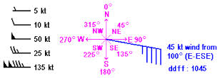
http://www.xcskies.com/community/faq/reading_barbs

- Draw a wind barb to represent a wind velocity of 35 knots blowing from the southwest at an angle of 250° (as measured from 0° North).

Although wind barbs indicate the direction the wind is coming from, when using wind velocity vectors it is more common to indicate the direction that the wind is blowing towards.

- What is the direction that the wind is blowing towards in the wind barb you drew above?

Use the wind map found at Unisys Weather Map: http://weather.unisys.com/upper_air/ua_const.php?plot=3k&inv=0&t=cur to complete the following questions.

- Select a map of upper air conditions at 3000 feet. Estimate the wind speed (knots, mph, and km/h) and direction the wind is blowing towards (degrees measured from 0° North) in Harrisonburg, VA.

- Now look at the wind velocity in Virginia at 30,000 feet. This is typical cruising altitude for a commercial plane. Estimate the wind speed (knots, mph, and km/h) and direction wind is blowing towards (degrees measured from 0° North) in Harrisonburg, VA.

Resultant Velocity
- Imagine that you are flying a plane over Virginia. Your altitude is 30,000 feet. The controls in the plane are set so that you are headed due North at 400 km / h. Draw a vector to represent your plane’s velocity. Make sure to draw it to scale.

- What was the wind velocity (speed in km / h and direction) over Virginia at 30,000 feet? Draw this wind velocity vector so that its tail is at the head of your plane’s velocity vector. Make sure to draw it to scale.

- What is the plane’s resultant velocity?

- Do your results make sense? Why or why not?

Analytical Addition of Vectors
Another way to add vectors is to use mathematics, particularly the Pythagorean theorem and / or trigonometric functions of sine, cosine, and tangent.
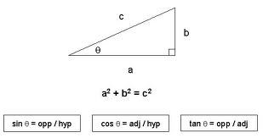

Real Time Flight Data
- Go to the Flight Tracker Web Site (www.flightstats.com) and select “Track Random Flight”. Record all of the following information.

Flight Number
Distance to Originating Airport
Distance to Destination Airport
Aircraft
Ground Speed | KPH: | MPH:
Altitude
Bearing
Position | Latitude: | Longitude:

Determine Resultant
- Draw a diagram like the one below that shows all of the following information: altitude, current location, arrival location, and distance to arrival location. Make sure that altitude and distance are given in the same units.
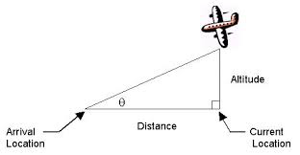

- Find the distance between the plane’s location in the air and the arrival location on the ground (the resultant) using the Pythagorean theorem. How does this compare to the ground distance to arrival location?

- Find the angle (q) that the plane makes with the ground (degrees) using one of the trig functions. Show your work.

- Draw a sketch of the triangle you drew above to scale. What would happen to the resultant if the angle (q) got even smaller? What would happen to the resultant if angle (q) got larger?

- Should the angle the plane makes with the ground be similar to the plane’s directional heading? Why or why not?

Practice
- A captain is heading his boat directly across a river with a very strong current. As the first mate, you must advise him how the river current will affect the boat’s movement. Prepare a drawing / diagram that you can use to show the captain the boat’s resultant velocity.

Vector Components
Using the flight information you found in the previous lesson answer the following questions:

- What is the definition of plane speed?

- What are the units for speed?

- What is the plane’s speed for the flight you selected in the previous lesson?

Resolving Vectors into Components
Assume that your flight is going to start its descent to the arrival location from its current position and that it will maintain its current velocity. Also, assume that the angle the plane makes with the ground is the same as you calculated in the previous lesson.

There is a highway directly below the flight path of the airplane and a car directly under the plane’s current position is racing to the airport to meet the plane. Vector components can be used to determine how fast the car would have to be driving to meet the airplane when it lands.

- Draw a diagram similar to the one you drew in the previous lesson but shows the plane’s speed (km / h), the angle the plane makes with the ground, current location, arrival location, and car speed. Include all values you know.
- Indicate the horizontal and vertical components of the plane’s velocity on your diagram. For example:
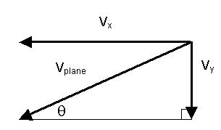
  - Which component represents the velocity the car should go?

  - What velocity would the car need to go to meet the plane at the airport?

  - Why might the car velocity you determined above not be an accurate value?

  - What is the plane’s vertical rate of descent?

Practice
- Explain how you could find the height of a tree, flagpole, or other tall object using only a protractor, meter stick and your knowledge of trigonometry. Assume that because of certain limitations you are not able to measure the height directly.

- Air traffic controllers need to know the cloud ceiling at the airport which is the distance between the clouds and the ground. Devise a method that could be used to find this distance using trigonometry.

Frames of Reference
Ever wonder why things look like they are moving more slowly or more quickly from a different perspective? It all has to do with your frame of reference.

How Fast Are You Going?
Look at the image below. To you, the observer, standing on the ground it looks like both planes are going 100 km / h. In other words, each plane’s velocity with respect to the ground is 100 km / h.
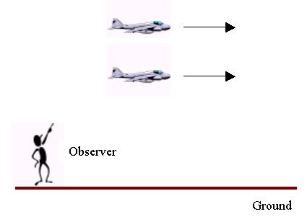
- What if, instead, you were inside one of the planes looking at the other plane? What would the other plane’s velocity appear to be from that perspective?

The planes are now moving at the same speed but in opposite directions.
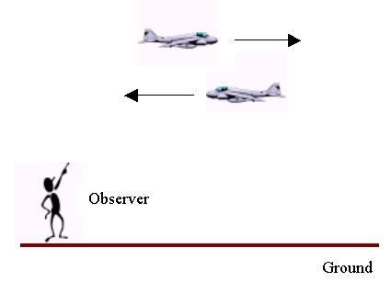
- If you were inside one of the planes in this picture, what would the other plane’s velocity appear to be from that perspective?

So Many Velocities
The measured velocities for objects in motion may be different depending on your frame of reference. Remember that velocity is a vector quantity so it is speed and direction. For airplane navigation there are three different velocities that are important:

Plane’s Ground Velocity: Velocity of the plane with respect to the ground.
Plane’s Air Velocity: Velocity of the plane with respect to the air.
Wind Velocity: Velocity of the air with respect to the ground.

- A plane’s ground velocity is the vector resultant of the plane’s air velocity and the wind velocity. Draw a vector diagram depicting this.

- Write an equation to represent the addition of these vectors.

- Use the flight information you found previously. Look at the speed given for the flight.
- Does the speed of the plane represent ground speed or air speed?

- What is the difference between ground speed and air speed?

- What are the units for speed?

- Why do you think the term speed is used instead of velocity?

A Look Inside the Cockpit
- Research at least five instruments in the following diagram and describe the information they communicate to a pilot and why it is an important tool for flying.

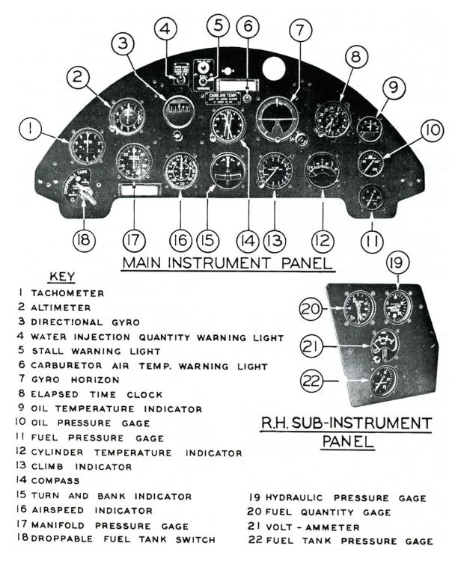

- _______________________________________________:

- _______________________________________________:

- _______________________________________________:

- _______________________________________________:

- _______________________________________________:

Practice
- A Navy pilot needs to land his plane on an aircraft carrier. Which way should he approach the carrier: from the rear or from the front? Why?

- There is conflicting testimony in a case regarding an airplane crash on the ground. An observer on the ground claims that the plane was traveling 100 km / h during landing. The pilot argues that he was only going 65 km / h. What might account for the different claims?

- What do you think are the most important navigation instruments available to a pilot? Why?

Relative Velocity
- Go to the Flight Tracker Web Site (www.flightstats.com) and select “Track Random Flight”. Record all of the following information.

Flight Number
Distance to Originating Airport
Distance to Destination Airport
Aircraft
Ground Speed | KPH: | MPH:
Altitude
Bearing
Position | Latitude: | Longitude:
Current Time

- Find the exact locations of the plane’s departing, arrival, and current locations. Use latitude and longitude coordinates to pinpoint the locations.

Location | Latitude | Longitude
Departing
Current
Arrival

- Plot the plane’s departing location, arrival location, and approximate current location on a map. Use latitude and longitude coordinates if you are not sure where the locations are. Draw a straight line between the current location and the arrival location. Show this to Ms. Belton when you’ve completed this task.

- Find the plane’s current directional heading in degrees. This is the angle of the line you just drew as measured from 0° North.
- Estimate the plane’s heading in degrees off of your map using a compass rose / protractor.

- Check your work by entering the flight’s current closest city and arrival city (or latitudes and longitudes) on the How Far Is It? web site (http://www.indo.com/distance/) to find the plane’s directional heading in degrees.

- What is the plane’s ground speed (km / h)?

Real Time Wind Data
- Find the wind speed (in knots) at the plane’s current location and the approximate altitude that the plane is flying.

Wind Speed: Altitude:

- Convert the wind speed from knots to km / h.

- Determine the precise direction the wind is blowing towards (degrees measured from 0° North) using a compass rose / protractor.

Flight Data Summary
- Summarize the following information you have obtained so far about this flight in this lesson. You will need the information for the next part. Be sure to include units.
Plane’s Ground Speed and Directional Heading
Wind Speed and Direction

Determine Air Speed
As a pilot, you must determine at what velocity (air speed and direction) to fly a plane to compensate for wind and to maintain your ground speed. Using the flight and wind data from above, construct a vector diagram according to the directions below. The diagram will help you determine the plane’s air speed and course heading.

  - In the following speace, place a dot to represent the plane’s current location. Then, using the plane’s directional heading in degrees and the plane’s ground speed, draw a vector from this point. The vector should be located with its tail at the plane’s current location. Use an appropriate scale (e.g. 1 cm = 50 km / h) to represent the ground speed. Make sure to indicate on your diagram that this vector represents the ground speed.
  - Plot the wind speed vector on your diagram with its head at the same location as the head of the ground speed vector. You should now have two vectors with both heads located at the same point. The direction of the wind speed vector should represent the direction the wind is blowing towards (degrees) and the length of the vector should represent the speed of the wind (drawn to scale). Make sure to indicate on your diagram that this vector represents the wind speed.
  - The air speed and direction can be determined using the previously plotted vectors. The air speed vector should be drawn with its tail at the plane’s current location and its head at the tail of the wind speed vector. Think of it this way: The air speed vector should be head to tail with the wind speed vector. Air speed and wind speed are both component vectors in this diagram. Ground speed is the resultant of the air speed and wind speed vectors.

- At what air speed should you fly the plane?

- What direction (degrees as measured from 0° North) should you head the plane?

- Think about your results, especially with respect to the wind. Do they make sense? Why or why not?

Practice
- A small p lane requires an airspeed of 45 m/s for lift-off. If there is a wind speed of 10 m/s, would it be better to take off with or against the wind? Why? Use vector analysis to provide a general recommendation as to whether planes should take off with or against the wind.

Estimating Arrival Time
One of the most common questions travelers have is “when will I get there?” A pilot can estimate the time of arrival of the flight by knowing the ground speed and distance to the arrival city. The distance between two cities can be estimated by maps but how does the pilot actually determine the ground speed?

Inside the cockpit, the pilot can read the air speed indicator and the heading indicator to get both of these values. By knowing the air speed, directional heading, and the wind velocity at the plane’s altitude the pilot can determine the ground speed. In this lesson, you will predict the arrival time of an in-flight plane based on an assumed air speed.

Flight Data Summary
- Use the flight data and information calculated in the previous lesson. Assume the plane runs into turbulence and the pilot decides to reduce the air speed by 25% but stays on the same course and heading. Record the following information:

Air speed (km / h) and directional heading (degrees)
Reduced air speed (km / h) and directional heading (degrees)
Wind speed (km / h) and directional heading (degrees)
Current Time of Arrival at Destination

Determine Ground Speed
In the following space, place a dot to represent the plane’s current location. Draw (to scale) the reduced air speed vector on this diagram. The air speed vector should be located with its tail at the plane’s current location. Draw the wind speed vector on the diagram (head to tail with the air speed vector) and at the correct directional heading as measured in degrees. Air speed and wind speed are both component vectors in this diagram. Ground speed is the resultant of the air speed and wind speed vectors.

- What is the new resultant ground speed?

- How does this ground speed compare to the original ground speed given on the Flight Tracker flight information page?

Estimate Arrival Time
- What is the distance (in km) from the plane’s current location to the arrival city?

- Use the new ground speed and the distance to the arrival city to calculate the time it will take to reach the arrival city. How long will the flight take to reach its destination?

- What time will it be in the arrival city? (take into account time zones)

- How does this time compare to the original estimated time of arrival?

- Do your results make sense? Why or why not?

Practice
- Imagine Earth rotated in the opposite direction. How might this affect arrival time?

- Imagine Earth rotated at a different rate. How might this affect arrival time?

- A pilot for a major airline needs to fly from Newark, New Jersey to Chicago, Illinois in under three hours in order to keep to the airline’s daily timetable.
- Assuming that the flight is scheduled to take off now, how fast and at what heading does the pilot need to fly the plane in order to keep to the schedule?

- What will be the estimated time of arrival (ETA) in Chicago?

- What might help the pilot beat the ETA? Explain.

Test Flight - Project
Now that you’ve learned all about Navigational Vectors it is time to test your skills.

- Use the Flight Tracker web site (www.flightstats.com) to select a random flight for your test flight. Record the following information given for your selected flight. You may need to search a little to find all of it. Use the most current reported data.

Flight Number
Distance to Originating Airport
Distance to Destination Airport
Aircraft
Ground Speed | KPH: | MPH:
Altitude
Bearing
Position | Latitude: | Longitude:
Current Time

- What is the wind speed (km / h) and wind direction (degrees) at the plane’s location?

Wind Speed: Wind Direction:

- At what air speed (km / h) and course heading (degrees) is the pilot flying the plane? Use vectors to determine this.

Airspeed: Course Heading:

Emergency!
As a pilot, you must be prepared for any situation. Suddenly a medical emergency arises. You must land the plane as quickly as possible or you will lose a passenger. You must choose an airport where you will land the plane.
- Identify two nearby airports where the plane could land. Don’t forget to consider the airport where the plane departed.
  - U.S. Airport Information – www.airnav.com/airports/
  - Airport Locator by State – www.ifly.com/airport-search

Airport #1 Airport #2

- Determine the distance and directional heading (degrees) from the plane’s current location to each of the airports you have selected.

Airport #1 Airport #2

- Assuming you maintain your current air speed, what direction (degrees) should you head the plane to reach each of the airports? Remember, you need to take into account wind speed. Use the following instructions to help in drawing the vector diagrams.

Vector Diagram Instructions
  - In the following space, draw a dotted line across the page at the same directional heading (degrees) as the heading you determined for one of the airports in Step 6.
  - Place a dot somewhere on the dotted line and label it Airport #1.
  - Draw the wind speed vector on your diagram so that the head is at Airport #1. Make sure to draw it to scale and to use the correct directional heading (degrees).
  - Use the same air speed that you determined in Step 4 above. Draw this vector to scale so that its head is at the tail of the wind speed vector and its tail intersects somewhere on the dotted line. It will not be at the same directional heading you determined in Step 4.
  - You should now see your air speed vector head to tail with the wind speed vector. The tail of the air speed vector indicates the plane’s current position.
  - The ground speed vector is the vector from the plane’s current position to Airport #1.
  - Repeat this for Airport #2.

Airport #1 Airport #2

- What are the new ground speeds (km / h) to each of the airports? (Refer to your new vector diagram.)

Airport #1 Airport #2

- Using the new ground speeds and distances to each of the airports, determine how long it will take you to reach each of the airports.

Airport #1 Airport #2

- What other factors besides time might you need to consider when deciding which airport to fly to?

- Which airport should you fly to? Why?

- What will be your estimated time of arrival to your selected airport?

- Complete a Pilot’s Incident Report (write at least one paragraph) to document what happened and why you made the decisions you did.

